**RESPONSIVE SOCIAL MEDIA WEBSITE WITH THEME CUSTOMIZATION USING HTML, CSS & JAVASCRIPT**

MINOR PROJECT REPORT

By

**AWADHESH JINDAL (RA2211003011520)**

**ADITYA ROY (RA2211003011539)**

**APARIJIT CHAKRABORTY (RA2211003011540)**

Under the guidance of   
**Dr. Aswathy K Cherian***In partial fulfilment for the Course*

of

**21CSC203P – ADVANCED PROGRAMMING PRACTICE**

In B.TECH – CSE CORE



**FACULTY OF ENGINEERING AND TECHNOLOGY**

**SCHOOL OF COMPUTING**

**SRM INSTITUTE OF SCIENCE AND TECHNOLOGY**

**KATTANKULATHUR**

**NOVEMBER 202**

**SRM INSTITUTE OF SCIENCE AND TECHNOLOGY**

**(Under Section 3 of UGC Act, 1956)**

**BONAFIDE CERTIFICATE**

Certified that this minor project report for the course **21CSC203P** **ADVANCED PROGRAMMING PRACTICE** entitled in "Responsive Social Media Website With Theme Customization Using HTML CSS & JavaScript" is the bonafide work of **Awadhesh Jindal (RA2211003011520), Aditya Roy (RA2211003011539) & Aparijit Chakraborty (RA2211003011540)** who carried out the work under my supervision.

# SIGNATURE

**Dr. Aswathy K Cherian**

**Assistant Professor**

**Department Of Computing Technologies**

SRM Institute of Science and Technology

Kattankulathur

# ABSTRACT

The project, “Responsive Social Media Website with Theme Customization using HTML, CSS & JavaScript”, aims to develop a user-friendly social media platform that allows users to interact and share content with ease. The website is designed to be responsive, ensuring optimal viewing and interaction experience across a wide range of devices. One of the key features of this platform is the ability for users to customize the theme of their profile using HTML, CSS, and JavaScript. This not only enhances the user experience but also adds a personal touch to each profile. The project leverages the power of HTML for structuring content, CSS for styling and layout, and JavaScript for dynamic interactivity. The outcome is a robust social media platform that offers a unique blend of functionality, aesthetics, and personalization.

# ACKNOWLEDGEMENT

We express our heartfelt thanks to our honorable **Vice Chancellor Dr. C. MUTHAMIZHCHELVAN**, for being the beacon in all our endeavors.

We would like to express my warmth of gratitude to our **Registrar Dr. S. Ponnusamy,** for his encouragement.

We express our profound gratitude to our **Dean (College of Engineering and Technology) Dr. T. V.Gopal,** for bringing out novelty in all executions.

We would like to express my heartfelt thanks to Chairperson, School of Computing **Dr. Revathi Venkataraman,** for imparting confidence to complete my course project

We wish to express my sincere thanks to **Course Audit Professors Dr. Vadivu. G , Professor, Department of Data Science and Business Systems and Dr. Sasikala. E Professor, Department of Data Science and Business Systems** and **Course Coordinators** for their constant encouragement and support.

We are highly thankful to our Course project **Dr. Aswathy K Cherian, Assistant Professor, Department of Computing, SRMIST ,** for herassistance, timely suggestion and guidance throughout the duration of this course project.

We extend my gratitude to our **HOD, Dr. Pushpalatha, Professor & Head, Department Of Computing Technology, SRMIST.**

Finally, we thank our parents and friends near and dear ones who directly and indirectly contributed to the successful completion of our project. Above all, I thank the almighty for showering his blessings on me to complete my Course project.

**Index**

|  |  |  |
| --- | --- | --- |
| **SL NO.** | **CONTENT** | **PAGE NO.** |
| **1** | **INTRODUCTION** | **8** |
| **2** | **PROJECT OVERVIEW** | **9** |
| **3** | **REQUIREMENTS** | **10** |
| **4** | **ARCHITECTURE**  **&**  **DESIGN** | **12** |
| **5** | **DATABASE**  **EXPLANATION** | **18** |
| **6** | **RESULT**  **&**  **DISCUSSION** | **20** |
| **7** | **CONCLUSION** | **22** |
| **8** | **REFERENCE** | **23** |

1. **INTRODUCTION**

In the dynamic landscape of the digital era, social media platforms have become integral to our daily lives, serving as conduits for communication, collaboration, and self-expression. As the demand for personalized online experiences continues to surge, the development of a responsive social media website with theme customization becomes not only relevant but imperative.

This project report encapsulates the journey of conceiving, designing, and implementing a cutting-edge social media platform, adept at adapting to diverse devices and user preferences. The amalgamation of HTML, CSS, and JavaScript, the triumvirate of web development, has been harnessed to craft a seamless, visually appealing, and highly interactive user interface.

1. **PROJECT OVERVIEW**

Our objective was to create a social media website that transcends traditional boundaries, offering users an engaging and accessible platform that caters to their individual tastes. The responsive design ensures optimal user experience across a spectrum of devices, from desktops to tablets and smartphones.

Moreover, the incorporation of customizable themes elevates the user experience to a new echelon. Users can now tailor the visual aesthetics of their social media environment, fostering a sense of ownership and uniqueness.

1. **REQUIREMENTS**

**System Architecture**

**2.1 Frontend**

The frontend of the social media website will be developed using HTML, CSS, and JavaScript. The website must be responsive to ensure a seamless user experience across different devices, including desktops, tablets, and mobile phones.

2.1.1 **Responsiveness**

The website should utilize responsive design principles, including media queries, flexible grids, and flexible images, to ensure optimal display on various screen sizes.

**2.1.2 Browser Compatibility**

The website should be compatible with major web browsers, including but not limited to Google Chrome, Mozilla Firefox, Safari, and Microsoft Edge.

**2.2 Theme Customization**

Users should have the ability to customize the appearance of the website through theme customization options. The customization features should include:

**Color Scheme:** Users can choose from a predefined set of color schemes or define custom colors.

**Font Styles:** Users can select from a variety of font styles for the website interface.

**Layout Options:** Users can customize the layout of certain elements, such as the arrangement of posts and navigation menus.

**Functionality**

**3.1 User Authentication**

Users should be able to create accounts, log in, and log out. Passwords must be securely hashed and stored.

**3.2 Social Features**

**3.2.1 User Profiles**

Users should have profile pages displaying their information, posts, and customization settings.

**3.2.2 Posting and Sharing**

Users should be able to create, edit, delete, and share posts. The posts may include text, images, and links.

**3.2.3 Friend Requests**

Users should be able to send and accept friend requests.

**4.ARCHITECTURE AND DESIGN**

**Login/Register Page**

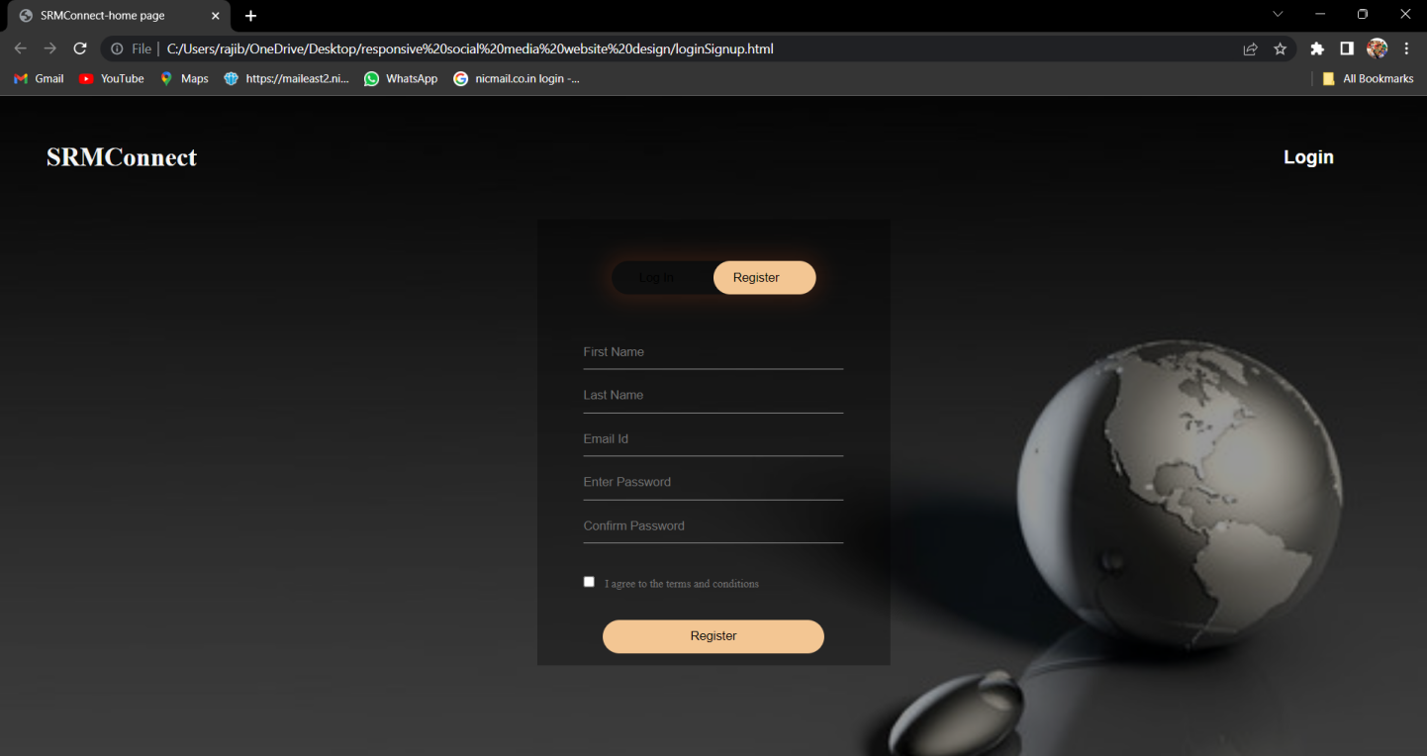

**Fig:4.1 - Login Page**

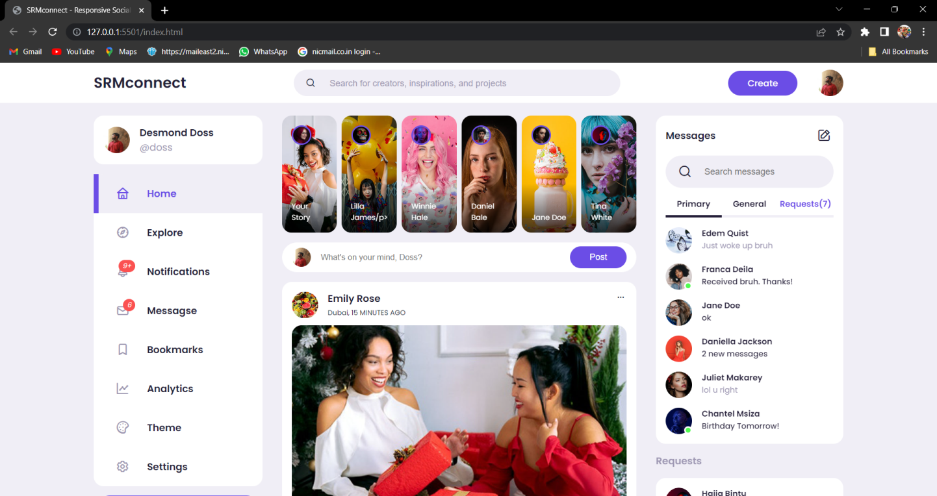**GUI of the Social media**

**Fig:4.2 – Home Page**

**Notification Pop-up**

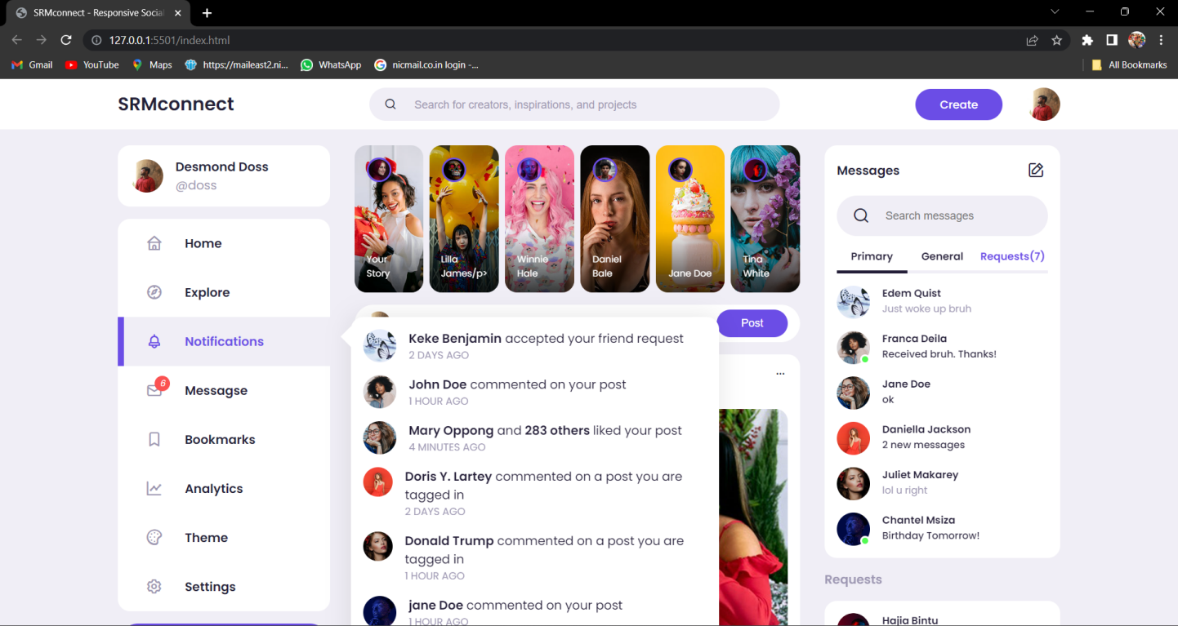

**Fig: 4.3 – Notification**

**Theme Customization (Font Sizes & Color Buttons)**

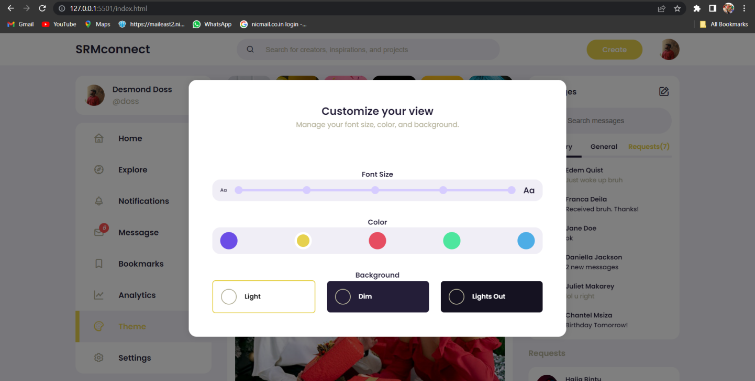

**Fig: 4.4 – Customizations**

**Dark Modes (Dim & Lights out)**

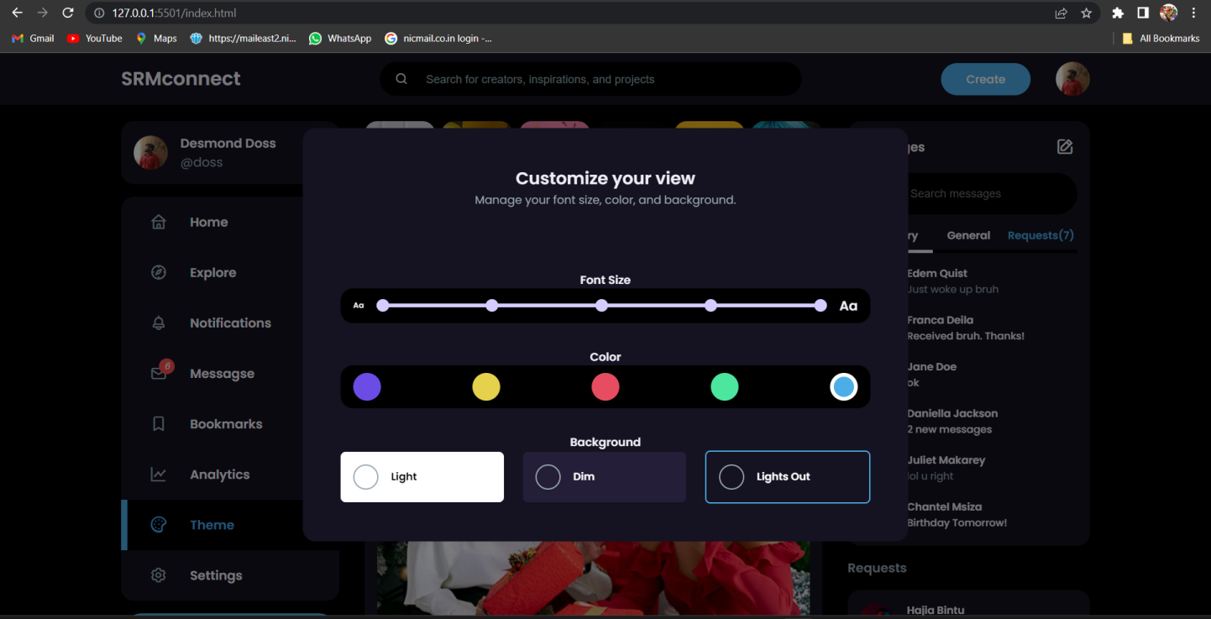

**Fig:4.5 – Themes**

**Mobile Interface Design**

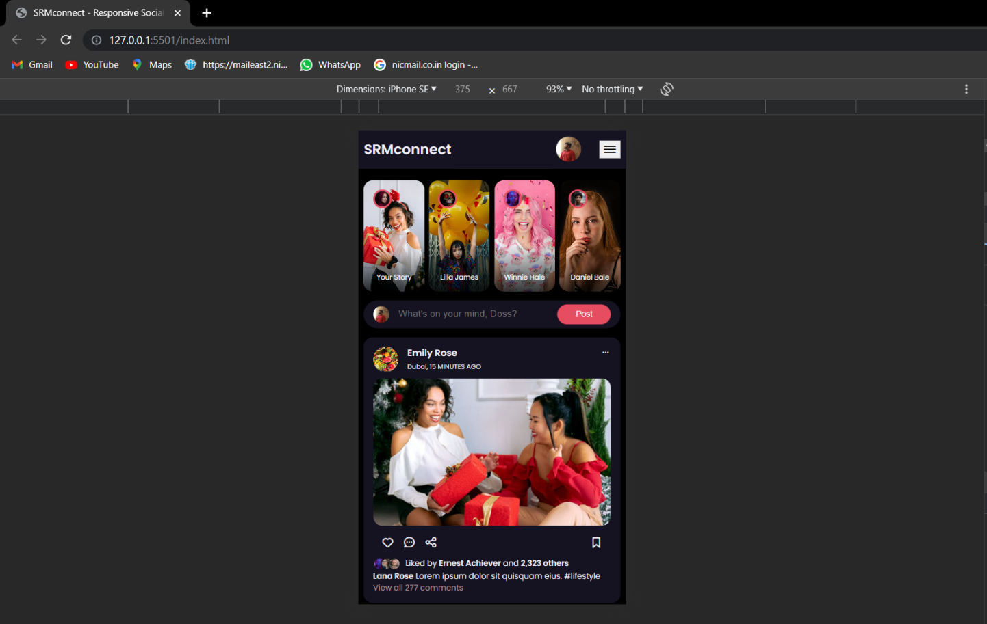

**Fig:4.6 – Mobile Interface**

**Opening Options**

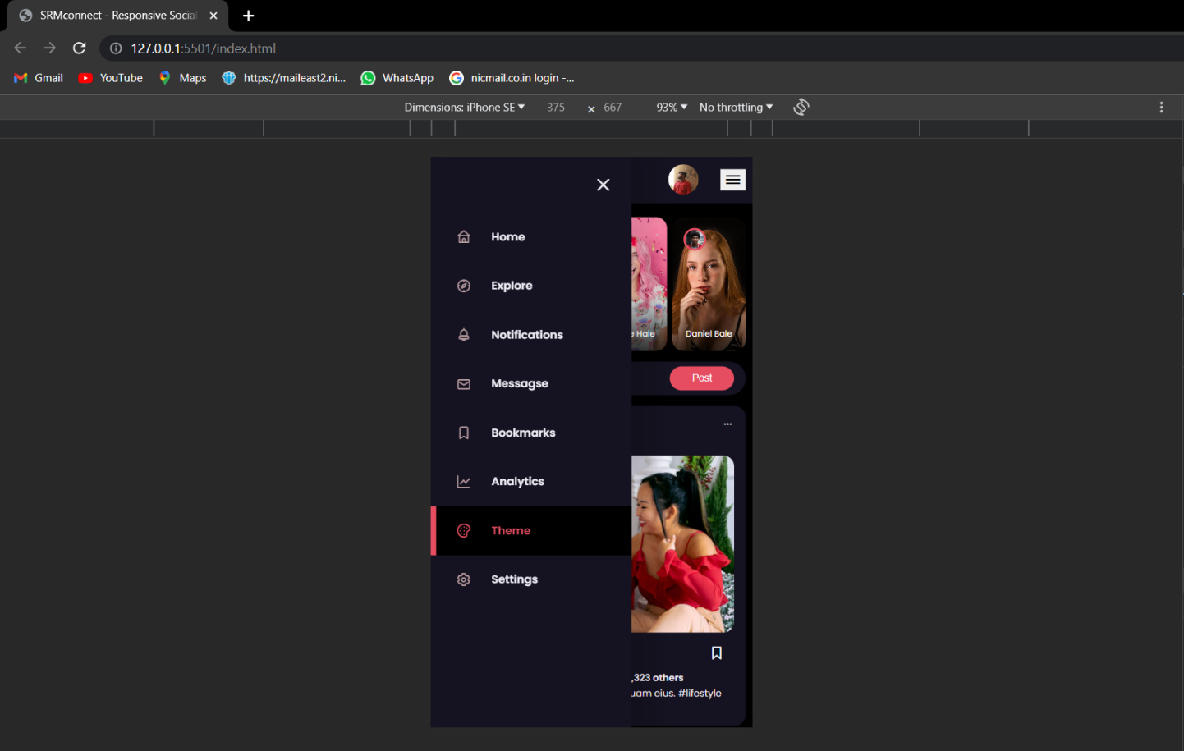

**Fig: 4.7 - Operations**

**For Our Database Design we’ve used MySQL**

DROP DATABASE socialnetwork;

CREATE DATABASE socialnetwork;

CREATE TABLE users (

user_id             INT NOT NULL AUTO_INCREMENT,

user_firstname      VARCHAR(20) NOT NULL,

user_lastname       VARCHAR(20) NOT NULL,

user_nickname       VARCHAR(20),

user_password       VARCHAR(255) NOT NULL,

user_email          VARCHAR(255) NOT NULL,

user_gender         CHAR(1) NOT NULL,

user_birthdate      DATE NOT NULL,

user_status         CHAR(1),

user_about          TEXT,

user_hometown       VARCHAR(255),

PRIMARY KEY (user_id)

);

CREATE TABLE friendship (

user1_id            INT NOT NULL,

user2_id            INT NOT NULL,

friendship_status   INT NOT NULL,

FOREIGN KEY (user1_id) REFERENCES users(user_id),

FOREIGN KEY (user2_id) REFERENCES users(user_id)

);

CREATE TABLE posts (

post_id             INT NOT NULL AUTO_INCREMENT,

post_caption        TEXT NOT NULL,

post_time           TIMESTAMP NOT NULL,

post_public         CHAR(1) NOT NULL,

post_by             INT NOT NULL,

PRIMARY KEY (post_id),

FOREIGN KEY (post_by) REFERENCES users(user_id)

);

CREATE TABLE user_phone (

user_id         INT,

user_phone      INT,

FOREIGN KEY (user_id) REFERENCES users(user_id)

);

**5.DATABASE EXPLANATION :**

**1. **Database Creation**:**

**- `DROP DATABASE socialnetwork;` drops the existing "socialnetwork" database (if it exists).**

**- `CREATE DATABASE socialnetwork;` creates a new database named "socialnetwork."**

**2. **Users Table**:**

**- This table is used to store information about the users of the social network.**

**- `user_id` is an auto-incrementing integer representing a unique user ID.**

**- `user_firstname` and `user_lastname` are strings for the user's first and last names, respectively. They are required (NOT NULL).**

**- `user_nickname` is an optional string for a user's nickname.**

**- `user_password` is a string for storing the user's password securely. It is required.**

**- `user_email` is a string for storing the user's email address. It is required.**

**- `user_gender` is a character (single letter) representing the user's gender, and it is required.**

**- `user_birthdate` is a date field representing the user's date of birth, and it is required.**

**- `user_status` is a character (single letter) for the user's status.**

**- `user_about` is a text field for additional user information.**

**- `user_hometown` is a string field for the user's hometown.**

**- The primary key for this table is `user_id`.**

**3. **Friendship Table**:**

**- This table is used to represent friendships between users.**

**- `user1_id` and `user2_id` are integer columns representing the user IDs of the two friends.**

**- `friendship_status` is an integer representing the status of the friendship.**

**- Both `user1_id` and `user2_id` are foreign keys, referencing the `user_id` in the "users" table.**

**4. **Posts Table**:**

**- This table is used to store posts made by users on the social network.**

**- `post_id` is an auto-incrementing integer representing a unique post ID.**

**- `post_caption` is a text field for the content of the post, and it is required.**

**- `post_time` is a timestamp representing the time when the post was made and is required.**

**- `post_public` is a character (single letter) indicating the post's privacy level (public or private).**

**- `post_by` is an integer referencing the user who made the post, and it is a foreign key referencing `user_id` in the "users" table.**

**5. **User Phone Table**:**

**- This table appears to be used for storing user phone numbers.**

**- `user_id` is an integer representing the user's ID and is a foreign key referencing `user_id` in the "users" table.**

**- `user_phone` is an integer for storing the user's phone number.**

**6.RESULT & DISCUSSION**

**1. **User Engagement and Growth**:**

**- Discuss the user engagement metrics, such as daily active users, monthly active users, and user growth over time.**

**- Highlight any significant changes or trends in user engagement and growth.**

**2. **Feature Usage and Adoption**:**

**- Describe the usage patterns of different features on the social media website.**

**- Analyze which features are most popular among users and which are less utilized.**

**- Discuss any user feedback related to specific features.**

**3. **Content Generation and Interaction**:**

**- Present data on the volume of content generated by users, such as the number of posts, comments, and likes.**

**- Discuss the level of interaction among users, including comments, shares, and other forms of engagement.**

**4. **Privacy and Security**:**

**- Evaluate the effectiveness of the implemented privacy and security measures.**

**- Discuss any security incidents or breaches and how they were addressed.**

**5. **Performance and Scalability**:**

**- Assess the performance of the social media website, considering factors like page load times, server response times, and downtime incidents.**

**- Discuss the scalability of the platform to handle increasing user loads.**

**6. **User Satisfaction and Feedback**:**

**- Summarize the results of user satisfaction surveys or feedback received from users.**

**- Analyze common themes and issues raised by users and how they were addressed.**

**7. **Challenges and Solutions**:**

**- Identify any challenges encountered during the project, whether technical, operational, or user-related.**

**- Discuss the solutions and strategies implemented to overcome these challenges.**

**8. **Impact on the Community**:**

**- Assess the broader impact of the social media platform on the user community.**

**- Discuss any positive or negative societal effects and any initiatives to promote positive online behavior.**

**9. **Future Developments and Enhancements**:**

**- Outline the future plans for the social media website, including new features, improvements, and updates.**

**- Discuss how user feedback and the results of this project will inform future development.**

**10. **Conclusion**:**

**- Summarize the key findings and insights from the project.**

**- Provide an overall assessment of the success and impact of the social media website.**

**11. **Recommendations**:**

**- Offer recommendations for further improvements, enhancements, or changes based on the results and discussions presented.**

**12. **Acknowledgments**:**

**- Acknowledge the contributions of team members, users, and any external partners who were involved in the project.**

**7.CONCLUSION**

**The Social Media Website project represents a significant endeavor to create a platform that facilitates online social interactions and content sharing. The database schema provided in the project is essential for storing user data, friendships, posts, and potentially phone numbers, ensuring data integrity and accuracy.**

**To successfully implement this project, it is crucial to consider various aspects, including security, scalability, user experience, and system performance. Additionally, the project should address user privacy, data protection, and adhere to relevant legal regulations.**

**Ultimately, the success of the Social Media Website project will depend on effective development, continuous monitoring, and adapting to the dynamic landscape of social networking, as well as addressing the ever-evolving needs and expectations of users.**

**8.REFERENCES**

**For the GUI Design we followed some YouTube videos .**

[**https://youtu.be/AiFfDjmd0jU?si=0HfBmdSx4NsLABCo**](https://youtu.be/AiFfDjmd0jU?si=0HfBmdSx4NsLABCo)

[**https://youtu.be/GMLsHHHOnjw?si=3NH0HEEcIQgnH2nP**](https://youtu.be/GMLsHHHOnjw?si=3NH0HEEcIQgnH2nP)